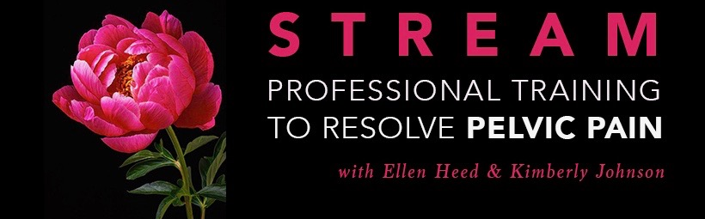
STREAM PROFESSIONAL TRAINING APPLICATION FORM To apply for the 2018 STREAM training, please complete this form, and return it via email. You can download this pdf to your computer, type your responses in and save the completed application OR you can print the form to complete manually and scan. Please email all applications to ellenheed@mac.com. We will then review your application, and reply to you via e-mail in a timely manner regarding your acceptance.
INTENSIVE TRAININGS JANUARY 25th - AUGUST 31st, 2018

HANDS-ON INTENSIVES:
JANUARY 25-28 Exiting the Shame Matrix
FEBRUARY 22-25 Touch Skills for Sexuality Professionals
MARCH 5-AUGUST 31st STREAM Professional Training
Your Information:
Name:_______________________________________________________
Address:_____________________________________________________
____________________________________________________________
Email address:_____________________________________________________
Phone number:____________________________________________________
Skype ID:_________________________________________________________
Emergency contact details:
Contact Name: ___________________________________________________
Contact Phone number:____________________________________________
Relationship:__________________________________________________

What makes you want to take this training?

What professional experience do you have that is related to this training?

How do you intend to use the learning from this course in your professional life and practice?

Are you aware of the laws where you live or intend to work about your scope of practice and ability to include genital touch in your work? If so, where do you stand with this?

What experience or training do you have with embodied practices (such as yoga, massage, meditation, martial arts, Tantra etc)?

What does your support network look like? (such as seeing a therapist, counselor, support groups, bodyworkers, friendship networks etc)

What do you think you may find challenging about the training?

Please tell us about any physical or mental health issues you have. This is important for us to know about in order to support you in the learning process.

If you are living with trauma, could you please provide a little more detail on how it currently affects you?

If you are living with a disability could you please provide a little more detail about the disability and how we can support your learning?

Are there any medications or substances you take regularly?

If you are in any process of recovery, for example from surgery, cancer, substance use, relationship break up, grief, psychosis or spiritual emergency, please tell us about it here:

How did you hear about the training?

What motivated you to contact us?

Is there any other information you wish to provide? Anything else that you would like is to know?

PLEASE NOTE:*** This training requires 10-12 hours a week of study and experiential erotic bodywork during the 10 weeks of online home study. Some students may not be required to take the January and/or February Hands-on Weekends if their professional experience already includes these skills. Every student will absolutely be required to attend the May 18-28 Hands-on Intensive. Genital touch and erotic exploration, both giving and receiving, will be a part of this training.
This STREAM training welcomes diversity in gender, sexuality, culture, physical ability and life experience.

